May 12, 1949

70 years ago, Ruth Robertson’s expedition reached Angel Falls

29 MAY 2019, JORGE M. GONZÁLEZ

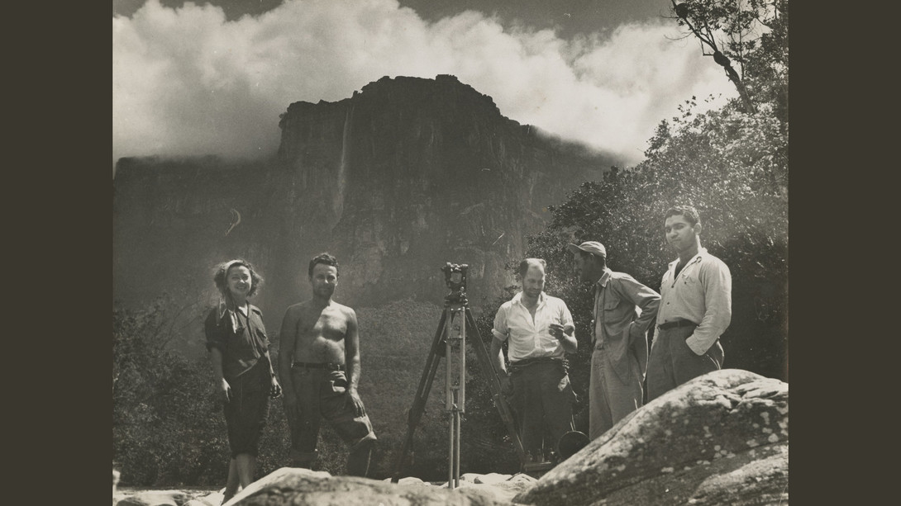

Ruth Robertson (American, 1905–1998), Members of the Angel Falls Expedition, 1949. Gelatin silver print, 7.25 x 9.5 in., Ruth Robertson Papers and Photography Collection, 25.2. Courtesy Harry Ransom Center

The large tabletop mountain Auyántepui is in Canaima National Park, Bolivar state, Venezuela. The first maps of the region called it Cerro Auyan. A name derived from the word Audanes, Mawariton spirits that reside on its summit. They are feared by the Pemón, inhabitants of the adjacent savannas. They never explored the currently known Devils Canyon, the place from where the Churun River emerges, after being joined by the Auyan River. The latter originates from a tall waterfall that flows out from the brim of Auyántepui.
That is the world’s tallest waterfall. It was seen from the air for the first time on November 18, 1933, by the pilot and explorer Jimmie Angel (frequently misspelled as Jimmy). Based on his altimeter, he calculated it was “one mile high.” From that moment on, he “adopted” it as his. Every time he was flying near it, he deviated to see it and to show it to anyone flying with him. Leonidas Richardson Dennison (1885-1953) narrated in Devil Mountain: The Lost World of Venezuela, his impression after seeing it from Jimmie’s plane:
“How is that for a waterfall?” Jimmie demanded.
I could not have answered him if I had tried. My eyes must have been popping right out of my head. I could only stare in amazement. It looked like an immense rope hanging over the canyon wall, and it fell for all 3,000 feet, possibly more, without interruption until it spread out into a billowy cloud of fine, fluffy mist. …”
In 1937, the explorers Gustavo “Cabuya” Heny (1903-1982) and Felix Cardona I Puig (1903-1982) found a route to the summit of Auyántepui. Several days later, Gustavo, his expedition partner Miguel Angel Delgado, Jimmie and his wife Marie (1906-1987), flew from Guayaraca, their camp on the south flank of Auyántepui, to a small savanna on the summit. Jimmie expected to find gold. While landing, the plane bogged down in the mud. It was then that Angel Falls and Jimmie became intertwined forever.
In 1938, General Eleazar López Contreras, president of Venezuela, issued a decree ordering to investigate the economic potential of the Gran Sabana. This generated the first detailed map of the region south of the Orinoco River. The name “Salto Angel” (Angel Falls) appeared in government-sanctioned maps, making it its official name.
By the end of the 1940s, very few knew about the waterfall. Among those few were the miners from around Urimán and Auyántepui and those that could remember the expedition news from the 1930s. Officially, no one had reached its base.
Seventy years ago, the night of May 12, 1949, a message sent from a base camp close to Angel Falls was heard in Caracas:
“Today, May 12, the expedition reached the waterfall. The weather was perfect. We are camping next to the feet of the falls and one of the expedition members is taking a shower.”
Explorers, led by the photojournalist Ruth Robertson (1905-1998), were sending regards to official and private personalities that contributed to the success of their expedition.
Ruth Robertson had an unordinary life. She was born in Taylorville, Illinois. Her mother, Marcella “Pinkie” Sewall, died when she was about 7 years old. She went to live with her grandmother. She died when Robertson was an adolescent. Then, she met her father, Jack Robertson, and moved to Peoria, Illinois, with him. He was a street photographer and taught her how to use cameras and how to develop and print photographs.
“By the time I was in my teens I was a popular girl with the kids who would come over to my house with their pockets full of Verichrome rolls for me to develop—gratis of course. … in Peoria, Ill, I … began the initiation into the secrets of coating, … I remember a shoe box of miscellaneous lenses which offered fascinating possibilities.
She found a job with the Peoria Evening Star. Her resolve led her to create the column “Peoria and Her People” which became an immediate success. After a while, she was hired by the Peoria Journal Transcript. She later went to Chicago, where she was hired by Acme News Pictures (today’s United Press International) and the Newspaper Enterprise Association. She did national photographic jobs and soon was frequently writing articles. She was the first press woman taking pictures from the infield in Wrigley Field in 1943. Where ever there was a relevant event, Ruth was there,
“Every day was different—a wheat harvest in Texas, a disaster in Minnesota, a football game at South Bend, a Democratic or Republican convention, a presidential train, the Dionne quintuplets, Nazi spy trials, ship launchings; everyday had its full quota of personalities – Madame Shiang Kai Shek, the Roosevelt’s, the Truman’s, Joe Louis, generals, war heroes, a complete cross-section of front-page coverage.”
World War II motivated many male journalists and press photographers to enlist. Women also enlisted as war correspondents and Robertson was no exception. She was assigned the Aleutians in Alaska. A friend of her youth, George Reith, remembered her as a singular woman:
“Ruth had many exploits in her 50-years career. But one of her main accomplishments was to prove that women are capable of doing what men can do. She had a drive that went beyond money, and even common sense, sometimes.”
After the war, she found a job she considered insignificant at the extinct New York Herald Tribune. She was bored. One night, she met her friend Clayton Knight (1891-1969), aviator, writer, and illustrator, for a drink and to meet with some Venezuelan pilots in a bar of Third Avenue,
“… they are pilots of the government airline in Venezuela with big plans to open up an international division to New York and Europe. They need English-speaking pilots, hopefully some who know a little Spanish, too.”
Their leader, after knowing about Robertson’s expertise and experiences, asked her if she would like to go to Venezuela, write articles about the recently hired pilots, and work on public relations for the company. He offered her three times her salary. She did not know the language, not even where Venezuela was located, but she accepted immediately.
Her friend Holst Fisher from Grace Line told her he had heard that one of the many Venezuelan waterfalls was “a mile high.” A few weeks later she was in Caracas. It was December 1946.
The company’s financial problems, among other things, eliminated her job just a few weeks after her arrival. Robertson was not discouraged and made a deal with the company’s head that would allow her to fly free between Caracas and New York for a year. She contacted magazines and newspapers in the U.S. with suggestions for articles and photographs that she could produce from Venezuela, a little-known country.
“Here was a whole chunk of the northern part of this continent to be explored and articles to be written and photographs to be taken and marketed in U.S. magazines. I felt confident that the frontier countries were where the good stories were to be found.”
She also contacted Venezuelan oil companies with offers to prepare promotional items while traveling the country and working at her own rhythm. She became acquainted with several pilots and early in 1947, she arrived in Ciudad Bolívar on the Orinoco River. She had decided to see the enormous waterfall that her friend had mentioned to her while in New York. She flew to Auyántepui.
She asked Art Jones, whose flying expertise she trusted, to fly her in his Douglas C-47 close to the canopy of the forest inside Devil’s Canyon in order to better appreciate the cataract. Jones invited Charlie Baughan to fly his DC-3 on their journey into Devil’s Canyon. His plane would serve as a size reference in a set of pictures she planned to take.
She took four similar photographs and after returning to Caracas, reproduced them to sell. She already planned to reach the waterfall by a land route. She believed that only from its base could the majesty of this natural wonder be appreciated.
While in Caracas, Robertson met Jimmie Angel at the American Club, and they became good friends. She mentioned to him that she planned to measure the waterfall and photograph it from its base. Jimmie responded:
“I already told you, it’s more than a mile high! The only way you’ll ever measure is from a plane, and I already did that. It’s 6,010 ft high … but the altimeter fluctuates a little … maybe three to six feet.”
After 18 months in Venezuela, Robertson traveled to New York. Talking to Clayton Knight, she was reminded about some of her pictures taken during a visit to the Sierra de Perijá with images Bari natives, commonly known as “Motilones.” The editors of National Geographic Magazine were interested in using some and Clayton suggested her to visit them. She should also let them know about her idea of an expedition to Angel Falls. She contacted Kip Ross, an editor, who invited her to Washington D.C. She showed them never released pictures of the Motilones and some of her Angel Falls pictures. She presented her idea of an expedition to Angel Falls, but they did not show any interest. However, one of the officers mentioned that if she was successful, they would like to have a first look at the story and the photographs.
Back in Caracas, Robertson started planning the expedition. One day in November 1948, Art Jones arrived at her house with a companion, Aleksandrs “Alejandro” Laime (1911-1994), a Latvian explorer and miner who lived around Auyántepui. Laime knew the area well and he had an idea about the land route to take to reach the falls. In her book “Churún Merú – The Tallest Angel,” Robertson related,
“Had he [Alejandro] ever been to the Churún Canyon [el cañon del diablo]? No, he said, but he had paddled on the Carrao River past Auyán-tepui … He had not tried to enter the canyon itself, as the Churún River appeared mostly rock-strewn and the jungle on both banks looked almost impassable, …”
Very probably Alejandro did not provide her with many details, or if he did, she did not mention them in her book. However, we now know that he had reached Angel Falls at least once before, either in 1946 or 1947. He had envisioned creating a tourist camp close by the waterfall. He mentioned it to a journalist from a Ciudad Bolívar newspaper. Curiously, Alejandro always recognized Ruth as the person that led the first successful expedition to Angel Falls.
Robertson and Laime had an immediate rapport and started working on the details of the expedition. Ruth had some financiers and an engineer. She mentioned to Laime the need for another engineer. The people from National Geographic had told her that she needed two to make the measurements of the waterfall official. Laime mentioned he graduated as an engineer from Riga University, in Latvia.
“… I breathed a sigh of relief over this, for it would mean that Laime could not only be the guide for the expedition, but also act as one of the engineers.”
Laime returned to Canaima. Prior to the start of the expedition, Robertson communicated with him and requested to clear an area for a landing strip. The expedition was planned to start by the end of May 1949, during the rainy season so that the rivers would be high and more easily navigated.
Many people wanted to be included. But from the very beginning, Robertson thought that a small group would be ideal. Everett A. Baumann, UPI correspondent in Venezuela, promised some financial aid, but she had to include Burch O’Neal, from the U.S. embassy. Unfortunately, the other condition was to depart earlier in April. Robertson reluctantly accepted the new conditions. The rains had not started by then and the waterfall would not be as full. At the last minute, Hamilton Holden from Princeton University Film promised to help with a large sum of money, but she had to take Ernest Knee (1907-1982), a Canadian photographer and filmmaker.
Robertson, her companions, and their provisions arrived at Uruyén. With their early arrival date, the contact with Laime had been lost. After waiting for two weeks, he finally arrived and decided to initiate the expedition from the South, not from the north as originally planned. Due to the long wait, some, including the engineer, returned to Caracas. Fortunately, Shorty Martin, an American engineer and aviator who was friends with Jimmie Angel and Robertson, brought a Mobil Oil’s civil engineer from Ciudad Bolívar. Thanks to the natives’ respect for Laime and the timely intervention of their leader, Capitán Alejo Calcaño, several Kamarakoto natives from San Rafael de Acanaan were incorporated to assist the expedition.
The expedition team included Alejandro Laime, guide an assistant engineer; Perry Lowrey (1916-1977), American engineer in charge of the measurements; Ernest Knee, who filmed the expedition, and the young Venezuelan Enrique Gómez, from the Ministry of Communications, who oversaw the radio. Ten Kamarakoto natives, including a woman, Juanita, were key to the expedition’s success. Ruth Robertson, who planned the enterprise, was the leader of the group.
After traveling upriver in curiaras (canoes) for few days, crossing an enormous mass of green forest, the explorers were in the Devil’s Canyon. On May 11, around 2:30 P.M., they could see the waterfall at a distance. Seeing the waterfall made them happy and euphoric. Their final goal was in reach!
On Thursday, May 12, they woke up early to start their hike to the waterfall. About 11 in the morning, the group arrived at a small promontory above a rock. As a huge lookout, they could see not only Angel Falls but all the valley formed by the Auyán River. Down the river, they noticed the camp where they had slept the previous night. In her field notes, published a few days after the expedition in the Caracas Journal, Robertson mentioned,
“I’m at the base of Angel Falls, por fin. The roar of the falls is deafening, the spray is taken by the wind every so often and whirled in spirals over the huge rock we’re sitting on and we get drenched. The big bowl cut out of rock at the bottom of the Falls is a tremendous amphitheater providing a spectacle that we know greets our eyes for the first time. And we feel like a small select audience, sitting here on this rock on a high promontory, just opposite.”
The next day, Friday 13th, Lowrey, Laime, and some natives built a small path through the gravel, prepared the theodolite, and started the measurements to calculate the height of the waterfall. Robertson and Knee were filming and taking photographs. Gómez was attending the radio. Congratulation messages were heard during the morning and evening contacts. The measurements were finished on Saturday: Angel Falls measures 3,212 ft., with a greatest single drop of 2,648 ft.
They started their return trip on Sunday, May 15th. On Wednesday, May 18th, Knee, Gomez, Lowrey, and Robertson were in the Ciudad Bolivar airport ready to fly to Caracas. Once there, excerpts of Robertson’s diary appeared in the Caracas Journal. A few weeks later, she met with Kip Ross and showed him her story and photographs that a will cover 36 pages of the November 1949 issue of National Geographic Magazine. Robertson remained in the news for months after her extraordinary achievement.
Scott Eisenstein, a producer associated with the Duncan Group in Chicago, wrote about her successful expedition as follows:
“She was a real risk-taker and achieved a great deal, even though her whole career was like pushing a boulder uphill. The expedition was led by a woman at a time when very few women were taken seriously as adventurers. She had no experience in mounting or leading an expedition, but she had so many things going for her: a fearless persona, strength, good humor and an unflappable will to succeed.”
Robertson’s following decades were interesting. She married pilot Charles C. Marietta (1905-1980). She became the editor of the Daily Journal (previously Caracas Journal), and after living for more than 12 years in Venezuela, she moved to Mexico. During the mid-1960s, she returned to the U.S. to live in Rosenberg, Texas, where her remains rest today. She traveled the world, presented talks about her adventures, and met with many dignitaries, but for Ruth Robertson, her most important endeavor was to conclude with success the first expedition to reach the base of Angel Falls, to measure it, and to photograph it in its maximum splendor.
In the May 2nd, 1955, issue titled, “Speaking of Pictures. Comparison for a Cataract,” Life magazine showed one of Robertson’s 1947 photographs of Angel Falls, a double page spread. In 1975, she published her book Churún Merú – The Tallest Angel in which she revived her experiences in Venezuela and provided details of her expedition. In 1990, National Geographic Magazine published the note “A Photographic Gift of a Venezuelan Trek,” which stated that she had donated many of her photographs to the Venezuelan National Library. This captured the attention of researchers from the University of Texas, in Austin. With the assistance of Robertson’s literary executor, Patricia Hubbard, they decided to highlight her life and her Angel Falls expedition in an exhibition celebrated during the Summer of 1993.
The Jimmie Angel Historical Project Archive in Eureka, California, contains a few of Robertson’s work related to her friendship with Jimmie Angel. Her numerous original documents, published or not, related to her career as a photojournalist and writer in the U.S.A. (including Alaska), Mexico, and Venezuela primarily, as well as many other photographs, are archived in the Harry Ransom Center of the University of Texas in Austin, where they can be consulted.

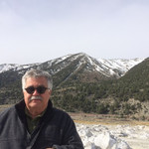

Jorge M. González

Entomologist, specialist in ecology, behavior and taxonomy of insects. Interested in past naturalists and explorers of the Neotropics.

Author profile

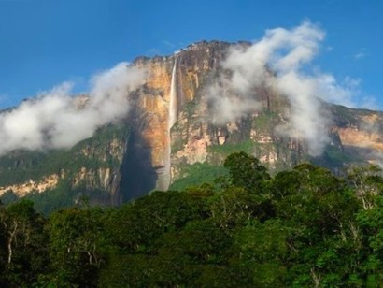

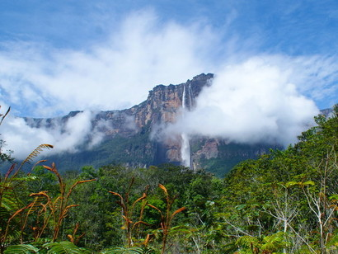

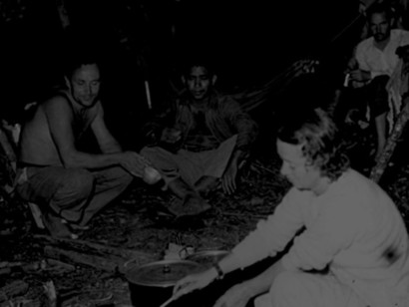
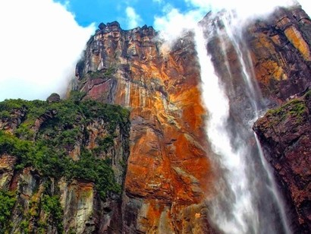

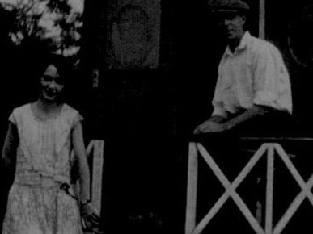
- Angel Falls
- Pemón porters and expedition members. Photo Ruth Robertson, Venezuelan National Library Collection
- Angel Falls
- Alejandro Laime, Enrique Gómez, Ruth Robertson (up front), Perry Lowrey. Photo Ruth Robertson, Venezuelan National Library Collection
- Angel Falls
- Ruth Robertson and her dad. Photo: George Reith

